Calculus 1 Name
Integration Review (odds only) Date

1) Calculate the area between the given limits, then calculate the total area by treating all areas as positive for the graph of . Sketch the graph and shade the area under the curve.
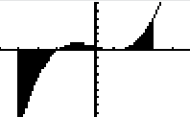

Since the 2nd and 3rd regions are both positive, they do not need to be split into two (but they can be split) Both methods are shown below.

OR

3) Calculate the area under the curve $g\left(x\right)=x^{4}−2x^{3}+3$ on the interval using 18 rectangles.
Left Hand Area = 104.598
Right Hand Area =134.58
Average = 119.589

Integrate the following. Make sure you show all your work (show u du steps if necessary).
5) $\int{\left(x^{3}−3x^{2}+x+4\right) \text{dx}}$ 7)$\int{\left(6x^{2}+8x\right){\left(x^{3}+2x^{2}\right)}^{4}\text{dx}}$

Integrate Solve for the constant of integration.
9) $\int{\frac{1}{\sqrt{x}}\text{sin}\left(\sqrt{x}\right) \text{dx}}$ 11)

Use the Fundamental Theorem of Calculus for Area to calculate the definite integrals.
13) $\int_{1}^{4}{\left(2x^{2}−4x−5\right) \text{dx}}$ 15) $\int_{1}^{8}{\left(5x^{23}−4x^{−2}\right) \text{dx}}$

Use the Fundamental Theorem of Calculus for Derivatives to find.
17) $G\left(x\right)=\int_{8}^{4x^{2}+2x}{\left(t^{2}−3t+2\right)} \text{dt}$

19) Find the mean (average) value and where it occurs for for the interval .

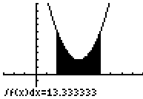 The average value is 3.333
3.333 =
It occurs at

